**BUSINESS IDEA:**

**DUAL VISION**



Beatriz Borrego, Madeleine Gómez, Tomás Macri

22 de febrero de 2023

2ºDAM, IES Francisco de Quevedo

SELECTION OF THE BUSINESS IDEA

|  |  |
| --- | --- |
| **NAME** | **Tomás Ezequiel Macri** |

|  |  |
| --- | --- |
| **NAME** | **Clara Madeleine Gómez Moreira** |

|  |  |
| --- | --- |
| **NAME** | **Beatriz Borrego** |

|  |  |
| --- | --- |
| **1. DESCRIPTION OF THE BUSINESS IDEAS TO BE ASSESSED** | |
|  | **IDEA 1: Description: main services and general characteristics** |
|  | Medical data and doctor appointments’ manager app  It would be simple and very intuitive so older people not used to technology could able to understand how to use it. Each user could customize its interface to reach the greatest number of customers, such as hospitals, private clinics or individual patients of all ages. There would be different options and functions; for example making appointments or organizing medical paperwork.  The interface could be adapted to each customers’ needs, depending on whether the user is a company or a patient. |

|  |
| --- |
| **IDEA 2 Description: main services and general characteristics** |
| Book Archive / Library  This app would have a database of books that could be filtered by type, author, title, series, etc. Users could save the books in a wish list as favorites, purchased and as part of a series. The interface would be easy to use, minimalistic and responsive so different devices could support it. The main page would show a list of purchased books and a list of read books so users could continue reading where they left off.  The books could be downloaded and edited by highlighting the text, adding notes, making drawings, etc. To set apart our project, we could add subscription plans so that users can access all the books in the database at a reasonable price. There could be several payment options: monthly,  annual... |

|  |  |  |  |  |  |  |  |  |
| --- | --- | --- | --- | --- | --- | --- | --- | --- |
|  | | **IDEA 3 Description: main services and general characteristics** | | | | | | |
|  | | App with augmented reality for interior design  The developed app would show virtual furniture in a room by using augmented reality software. The target market would be furniture, real state, building, interior design and architecture companies. Clients would have a custom database with all the furniture on their catalogues. In addition, the app would offer the option to add new furniture to their database. Nevertheless, the app offers default options such as modifying the dimensions or color of the registered furniture.  Apart from the furniture, elements such as walls, columns, ceilings could be previewed by adding wallpaper, wall paint, etc. | | | | | | |
| **Assessment criteria** | | | **Puntuación** | | | | **Remarks** | |
|  | | | **Idea 1** | **Idea 2** | **Idea 3** | |  |
| Necessary investment and available resources | | | 2 | 5 | 4 | | Lower score to higher difficulty |
| Potential demand | | | 2 | 3 | 3 | | The higher the demand, the higher the  value |
| Evolution of the number of consumers | | | 1 | 4 | 4 | | The higher the growth potential, the  higher the score. |
| Number of competitors | | | 4 | 1 | 4 | | The more competition, the lower the  score |
| Importance of competitors | | | 3 | 3 | 3 | | Stronger competitors, lower score |
| Bargaining power with suppliers | | | 5 | 5 | 5 | | The more possible providers, the  higher the score |
| Need for specific knowledge or qualifications | | | 4 | 4 | 3 | | Higher score if we have them or can  acquire them. |
| Need for sales channels | | | 2 | 1 | 4 | | The more complex the channels, the  lower the score |
| Original or innovative elements | | | 3 | 1 | 5 | | Highest score for originality and  innovation |
| Access to the right staff | | | 2 | 2 | 3 | | The higher the availability of staff, the  higher the score |
| Dedication required | | | 1 | 1 | 1 | | Higher dedication, lower score |
| Expected profitability | | | 3 | 2 | 5 | | The more profitable, the higher the  score |
| Similar examples of business success | | | 2 | 4 | 3 | | Higher score when there are similar  successful businesses. |
| Affinity with preferences and hobbies | | | 2 | 2 | 5 | | The higher the affinity, the higher the  score |
| Affinity with personal abilities | | | 2 | 3 | 4 | | The higher the affinity, the higher the  score |
| Family support | | | 3 | 2 | 5 | | The more support, the higher the  score |
| **TOTAL** | | | **41** | **43** | **61** | |  |

**REMARK:** Try to assess objectively. Discuss your ideas around you, ask for opinions and listen to them. If possible, contact professionals in the sector and share with them your proposals.

SELECTED IDEA

Software for interior design companies with augmented reality

Scope:

Companies located in Spain

Description:

Software that allows users to test interior design products and how they would look like in different environments.

In addition to the software, our company would modify the interface to adapt it to the clients’ requests.

We would offer customer service and technical service such as maintenance

Description of your product or service:

Functionality for companies:

Modify database: add or delete furniture to the database so that the clients can upload their own products

Change interface: adapt design to clients’ requirements

Change language: multilingual software based on clients’ requirements

Functionality for users:

Select colors

Change position: move and rotate the items within the environment

DEVELOPING OUR BUSINESS PLAN

|  |  |
| --- | --- |
| **NAME:** | **DualVision** |

|  |
| --- |
| Describe the Idea of business you are going to establish. |
| The activity of our company is:  Developing software by using advanced augmented reality technologies. Satisfy each company’s need when facing a specific target market.  Research the market and assess our software’s functionality and usability needs. We choose this business idea and not another because:  **It is an innovative technology in an area without much competition and many potential clients.**  **In addition, we are very interested in this field and this kind of technology and we want to keep on learning about it.**  It will cover the needs of most furniture and remodeling companies Our clients: |

The work process will be less time consuming and more efficient. Their potential number of consumers will be increased.

Expenses will be cut down for the companies, as customers would avoid taking previewed furniture back.

General public:

The furniture selection will be faster and simpler.

It gives customers a chance to test the product before buying, transporting and assembling it. It saves time for everyone involved.

|  |  |  |  |  |  |  |
| --- | --- | --- | --- | --- | --- | --- |
| **BUSINESS PROMOTERS** | | | | | |  |
| PERSONAL DATA | | | | | |
| Name and Surname | | Beatriz Borrego | | | |
| National Identity Card | | 02668653D | E-mail | [beatriz.borrego1@educa.madrid.org](mailto:beatriz.borrego1@educa.madrid.org) | | |
| Birthday | | 11/08/1992 | Adress | C/ Ricardo Ortiz, 57 | | |
| Phone number | | 620745758 |
| PROFESSIONAL DATA | | | | | | |
| Academic training | Academic degree | | | | Study center | |
| 1. University Degree in Translation and Interpreting | | | | Universidad Complutense de Madrid | |
| 2. Master’s Degree in Audiovisual Translation | | | | ISTRAD y Universidad de Cádiz | |
| 3. HNC in Movile App Development | | | | IES Francisco de Quevedo | |
| Further training | Studies | | | | Study center | |
| 1. | | | |  | |
| 2. | | | |  | |
| 3. | | | |  | |
| Work experience | Firm | | Occupation/work post | | Period | |
| 1. Freelance | | Translator | | May 2017 – Present | |
| 2. GBA Información Económica y Financiera  SL. (Madrid, Spain) | | Administrative | | Feb. 2020 – Present | |
| 3. Altagram (Berlin, Germany) | | Translator and Tester | | Feb. 2018 – Aug. 2018 | |
| 4.Media Interactiva  (Seville, Spain) | | QA Tester | | May 2016 – May 2017 | |
| 5. | |  | |  | |
| 6. | |  | |  | |
| Other data | Languages | | 1. English | | 2. French | |
| Technical knowledge | | 1. Programming languages: Java, Kotlin, Python | | 2. DataBase: Oracle, MySql | |

|  |  |  |  |  |  |  |
| --- | --- | --- | --- | --- | --- | --- |
| **BUSINESS PROMOTERS** | | | | | |  |
| PERSONAL DATA | | | | | |
| Name and Surname | | Clara Madeleine Gómez Moreira | | | |
| National Identity Card | | 53473791X | E-mail | [claragomezmoreira@gmail.com](mailto:claragomezmoreira@gmail.com) | | |
| Birthday | | 16/03/2001 | Adress | C/ Ciudad Encantada 9B | | |
| Phone number | | 623202513 |
| PROFESSIONAL DATA | | | | | | |
| Academic training | Academic degree | | | | Study center | |
| 1. High School Degree in Arts | | | | IES María Zambrano | |
| 2. HNC in Movile App Development | | | | IES Francisco de Quevedo | |
|  | | | |  | |
| Further training | Studies | | | | Study center | |
| 1. | | | |  | |
| 2. | | | |  | |
| 3. | | | |  | |
| Work experience | Firm | | Occupation/work post | | Period | |
| 1. Kids & Us | | English Teacher | | August 2020 – July 2021 | |
| 2. | |  | |  | |
| 3. | |  | |  | |
| 4. | |  | |  | |
| 5. | |  | |  | |
| 6. | |  | |  | |
| Other data | Languages | | 1. English  C2 level in English (Business English too) | |  | |
| Technical knowledge | | 1. Programming languages: Java, Kotlin, Python, SQL, Html, Css, Bootstrap, XML, etc | | 2. | |

|  |  |  |  |  |  |  |
| --- | --- | --- | --- | --- | --- | --- |
| **BUSINESS PROMOTERS** | | | | | |  |
| PERSONAL DATA | | | | | |
| Name and Surname | | Tomás Ezequiel Macri | | | |
| National Identity Card | | Y7451932S | E-mail | [emacri@educa.madrid.org](mailto:emacri@educa.madrid.org) | | |
| Birthday | | 09/07/2001 | 09/Adress | Calle Helsinki 25B, 28022 | | |
| Phone number | | 660046009 |
| PROFESSIONAL DATA | | | | | | |
| Academic training | Academic degree | | | | Study center | |
| 1. High School Degree in Computer Science | | | | Ort | |
| 2. HNC in Movile App Development | | | | IES Francisco de Quevedo | |
|  | | | |  | |
| Further training | Studies | | | | Study center | |
| 1. | | | |  | |
| 2. | | | |  | |
| 3. | | | |  | |
| Work experience | Firm | | Occupation/work post | | Period | |
| 1. IBAI SISTEMAS S.A | | Software developer | | January 2022 – Present | |
| 2. | |  | |  | |
| 3. | |  | |  | |
| 4. | |  | |  | |
| 5. | |  | |  | |
| 6. | |  | |  | |
| Other data | Languages | | 1. English | |  | |
| Technical knowledge | | 1. Programming languages: Java, Kotlin, Python, Html, Css, Bootstrap, XML, etc | | 2. DataBase: Oracle, MySql, Postgres, SQL | |

# Business Structure

Describe the different **functional areas** that appear in your company

### **- Information and Technology:** almost all businesses nowadays make use of computers and information systems. The Information Technology (IT) Department is responsible for the architecture, hardware, software and networking of computers in a business. Their main tasks include data management, development and operation of network and website maintenance.

- M**arketing area:** buying and selling.

* **Finance and accounting area:** search and management of capitals that allow investments and all the accounting functions of the company.
* **Human resources area:** personnel functions, prevention of occupational risks.

Draw an **organizational chart** that reflects the structure of your company

**Environment Analysis**

**Location or placement chosen for our business**

The placement chosen for our business is Madrid, Spain.

## Analysis of the main factors of the general environment

#### Economic:

Spain is a country where it is very safe to start a business, thanks to the political and financial stability that being part of the EU provides.

Furthermore, Madrid is the Spanish province with a highest medium wage in the country, allowing their inhabitants to make investments such as big as redesigning a house or, in some cases, buying and equipping a new property.

#### Sociocultural:

Spanish society, and mainly people who lives in Madrid, are likely to buy more than one property throughout their life, which means that they would have to redecorate their properties several times during this time.

#### Technological:

As it is a first world country, Spain is always one of the first countries to introduce new innovative technologies that will probably, in the near future, help our company to develop new features to our software.

#### International factors:

Due to the privileged location of the city, it will help us not to be far away from out potential national clients, in case that we need to settle a personal meeting or anything else.

In addition, in case that at some point we decide to change our scope to international companies, we would have the same time as many of our potential European clients.

## Analysis of the main factors of the specific environment

#### Competition:

Although there are a few companies that already have the software that we are trying to sell, their business works in a different way. Most of them have the software online and anyone can access to it. This will bring them more users, but not as many customization that this software in a specific company has. This is the case of Mazing, Wayfair….

On the other hand, one of the business top companies, IKEA, already developed this software, but only to implement it in their products.

#### Customers:

Apart from IKEA, there is no other furniture business (either local or multinational) that applies this technology as of now.

Given to this, we could have many potential customers, given the innovative of this software.

#### Substitute products:

The technology that we used to develop the software is brand new. Given to that, it is not likely that other technology may replace it (and be as cheap) as it in the coming years.

#### S.W.O.T ANALYSIS

After analyzing the general and specific business environment, you should prepare the SWOT matrix:

* + **W**eaknesses (weak points) and **S**trengths (strong points) of your business
  + **T**hreats (obstacles) and **O**pportunities provided by the environment

|  |  |
| --- | --- |
| Business weaknesses  Weak points ... "to overcome" | Threats from the environment Obstacles ... "to face" |
| New and unknown company  Lack of experience in company management  Limited resources to reach new potential clients  Limited initial funding | Increasing competition  New laws regarding technology  Big potential clients, like Ikea, could become competitors  Market demands to keep innovating |
| Business strengths  Strengths ... "to maintain and enhance" | Opportunities from the environment advantages "to take advantage of" |
| Trained and motivated owners with good technology skills  Cutting-edge technology Low investment needed  User-friendly and customized apps  Personal and individualized relationship with customers | Wide target audience  Qualified professionals available  Growing industry (augmented reality)  Better technologies and platforms to work with  Easy and economical to expand worldwide |

Brief conclusion of your SWOT analysis:

Our business greatest strengths and opportunities are related to technology. The world is more and more dependent on technologies and demand the latest developments. This is an opportunity and a threat because we can reach a large audience, but it is necessary to keep innovating to retain customers.

One of our perks is the relationship with our customers. We want to offer a personal customer service to be able to solve any issues promptly.

As entrepeneurs, we are very motivated and passionate about the project and we are well trained in technology. However, we lack experience developing a company. We don’t have many assets to invest, but we don’t need much funding to start the project.

Briefly define the competitive advantage that your business idea presents: We offer edge-cutting technology for everyday tasks.

Highly skilled workers.

Our app can be useful for big and small companies and individuals and it can be easily customized.

Personal customer services.

Once the main functionalities of the app are set, we can keep on growing our services easily to retain customers and reach new ones.

Discuss the strategies you will adopt in the initial development of your business idea:

First, we need to develop the main features of our software.

Then, it is important to obtain as much publicity as possible. Since we cannot anticipate much money and we do not have a known brand, a good way to show our app is by creating a website and implementing SEO techniques. We will also take part in app contests to be able to prove the quality of our project.

Our main initial goal is to reach a big company at national level, such as Leroy Merlin or Ikea, to offer them to test our software free. If they become our clients, it will be a great publicity boost and it will offer us the opportunity to grow internationally later.

At the same time, we will contact smaller companies related to real estate, interior design, construction… In this case, we will offer a special price so they can get to know our services.

Our intention is to make sure potential clients use our software for a short period for free or at a lower price so we can show them the quality of our product and retain them as customers thanks to our individualized services.

#### ”Corporate Social Responsability”

**Try to tell whoever can read your Business Plan:**

“… Our business is going to be responsible by incorporating different actions in the area of CSR in the management of the company, such as… destined to…, with the

following resources… and preparing an annual sustainability report that will be given to know through ...”

Our business is based on respect. It is the symbol of our work within our company, our customers and our community. We make sure all the procedures we follow, and the quality of our products reflects upmost honesty. The environment at Visual Studio allows for no kind of discrimination or disrespect.

We encourage our team to be positive and polite, as this is a way in which respect is shown and teamwork becomes enjoyable. In favor of collaboration and dignity, we advocate for dignity and equality. Gender, race, nationality, age and other such things are not relevant for us when it comes to having access to the same opportunities.

### Dual Vision is completely based on awareness, as we aim to provide people with a new reality and point of view by means of our software. We want to facilitate and contribute to our community’s economy. For that reason, we aim to be responsible contributors for our society and behave in a conscious way every step of the way.

As our internal and external environment deserves our deepest respect, we will be providing an annual impact report, making sure to be as honest as we can be and including those aspects we are still trying to improve.

### We show ambition in our work in order to achieve quality results, no matter how unfamiliar the path we need to take is, or how difficult it is. Creating simple solutions and value for our clients is our pleasure, even if it requires being adventurous and responsible with our performance. A desire for adventure is what takes us far, as we aim to discover newer and better ways to do what we do, regardless of what is expected from us. We do not allow ourselves to become boring or complacent in our ways.

We aim to find essence and purpose in our work, which matters as deeply as providing value in our services. . The purpose is what matters and that we provide value in our services. In Dual Vision, we spend resources and time to maximize our team potential. In this way, we exercise social responsibility.

### Whether it is our job or not, we want to lead by example and not only work for our clients, but for our socially responsible employees, who know our society, community and environment matters. For that, we will give each of our workers an extra day off each month to volunteer by contributing to a good cause and help our community.

#### ”Business Identity: DualVision”

**Business culture**

Mission Values Vision

Our mission is clear. We aim for everyone to see what we envision, by

means of both our advanced technology and deep enthusiasm!

We aim to teach, to learn and, most

important, to progress!

We stand by the side of equality, the beauty of diversity, and a deep respect for everyone. Honesty and hard work are at the top of our list.

We believe vision is completely based on perspective.

Because of that, we choose to see the world with a hopeful eye, aiming to bring the best we can to it and everyone.

**Corporate image**

Logo Colours Other elements



## INCORPORATION PROCESS AND SET-UP OF YOUR BUSINESS

### A. Classify your future company according to the classification criteria you know (economic sector, activity, size, ownership of capital, territorial scope …)

Size – small because our company initially has about 16 employees Economic sector – tertiary

### Activity – IT sector

Ownership of capital –

### Tomás Macri: 33%

### Madeleine Gómez: 33%

### Beatriz Borrego: 33%

### Territorial scope – national

b. Decide on a legal form for your future company and justify why you have chosen it.

#### LEGAL FORM OF THE COMPANY

**Identification of the company:** 96726936E **Name or Registered Name:** Dual Vision S.L. **Legal aspects of incorporation:**

* Public deed of incorporation (Articles of incorporation) before a Public Notary along with the Company’s Bylaws
* Registering in the Public Registry of Commerce
* Company’s Bylaws rules of internal functioning:
  + General assembly of partners: body that expresses the corporate will
  + Administrators: body that carries out administrative management of the social enterprise and that represents the company with third parties.

**Registered address:** C/ Martinez Villergas, 49

**Town and province:** Madrid, Madrid

**Corporate purpose / activity in which it is focused:** Software development

**Social capital:** 18000€

**List of partners:** Tomás Macri, Madeleine Gómez, Beatriz Borrego

**Liability for debts:** 12000€**,** computers, desks, technology patent

#### Capital contributed by each partner (if it is an individual company, no): 6000€

#### List of workers who have been hired: 16

#### Explain the reasons that have led you to undertake alone or create a company with other people:

By creating a company with partners, we have more money to invest.

In addition, we share the same passion and motivation to develop this project. We trust each other, have technical training and work well with each other.

#### Justify the legal form chosen for your company:

Limited Liability Company is the best option because we are a small company with few partners and low initial capital.

It is a safer form because partners are not be responsible for debts in a subsidiary way and our personal assets would be protected.

Thanks to the corporation tax, we can buy the necessary equipment without investing as much money

# INCORPORATION PROCEDURES

#### PROCEDURES FOR LIMITED LIABILITY COMPANIES

1. Public Central Registry of Commerce: registering the name of the company with the legal form adopted.
2. Spanish Tax Agency (Agencia Tributaria): request a provisional Tax Identification Number (NIF).
3. Public Notary: signing the incorporation of the company.
4. Ministry or Office of Finance: taxing corporate incorporation operations. Business creation is exempt from payment.
5. Public Registry of Commerce of the province: registering the company in the province it is settle.
6. Spanish Tax Agency (Agencia Tributaria): requesting a final Tax Identification Number (NIF).

<http://www.ipyme.org/es-> ES/creaciondelaempresa/ProcesoConstitucion/Paginas/SRL.aspx?cod=SRL&nombre=Sociedad

%20de%20Responsabilidad%20Limitada&idioma=es-ES

# START UP PROCEDURES (TAX OFFICE, SOCIAL SECURITY, LABOR ADMINISTRATION, LOCAL ADMINISTRATION, OTHER PROCEDURES)

[**http://www.ipyme.org/es-ES/creaciondelaempresa/Paginas/Tramites.aspx**](http://www.ipyme.org/es-ES/creaciondelaempresa/Paginas/Tramites.aspx)

**Generals:**

1. Tax Office (Agencia Tributaria)
   1. Census declaration: report the start of activity. 30 days before the start of the activity.
   2. Registration with IAE: register the activity. 10 days before the start of the activity. The model 036 needs to be filled.
2. Social Security
   1. Registration of the company in Social Security: in order to hire workers, our Social Security number needs to be obtained and it will be valid for the whole duration of the activity.
   2. Employee affiliation: by the use of the TA1 model, employees who have never worked will be affiliated and enrolled.
   3. Registration of workers: workers already affiliated will be registered through the model TA2 to be included in the corresponding Social Security regimen. Upon this, the company will begin paying the Social Security Contribution monthly.
   4. Registration of the employer in the Special Regime for Self-Employed Workers: the company’s partners will join the special regimen for self-employed workers. 30 days following the start date of the activity. A monthly fee must be paid.
3. Town Hall
   1. Activity license: planning permission to set up an office in which to carry out the activity.
   2. Registration in municipal taxes: the company must pay municipal rates for Water, Garbage disposal...
4. Public Registry of Commerce of the province
   1. Legalization of minutes of books, partners registration book, nominative shares registry book, registry book of contracts between the company and its shareholders
   2. Legalization of the log book, inventory and annual accounts book
5. Labor administration

a) Communication of the opening of the work center or resumption of activity: an application form has to be filled indicating the data of the company or work center, the activity to be carried out and the number of workers. 30 days before the start of the activity

1. Provincial Labor Inspection

a) Acquisition the working calendar: the calendar must be displayed visibly in the workplace

1. State Public Employment Service (SEPE)
   1. Registration of employees contracts
2. Industrial Property Registry
   1. Registration of the patent of our software to protect the company’s technical innovation regarding the augmented technology customization

**TAXATION. ECONOMIC AND FINANCIAL ANALYSIS. FINANCING. COMMERCIAL DOCUMENTS**

1. ***Taxation***
2. Indicate, from a tax point of view, which direct taxes affect your company and how you pay for them. Justify your answer.

* Fees paid for public services such as the water supply fee
* Personal income tax is paid by each of the members of the company. It is a progressive tax, meaning that, the more each partner earns, the more each will pay. The regime would be done by using an objective estimation utilizing the activity, the number of workers, the premises and the activity of the company.
* Dual Vision would also pay corporation tax (impuesto de sociedades), which applies a fixed taxation rate of about 30% for medium or big companies and a 25% for small companies.
* The economic activities tax would not require to be payed until after the first two years of economic activity within the legal person (the company)
* The company would annually pay the real estate tax, given the ownership of a small office building.
* Finally, the company would be subject to paying a tax on motor vehicles, as the company owns a couple cars shared by the three partners.

1. Indicate the VAT regime that applies to your company. Justify your answer.

* Companies do not need to pay this tax, as the only taxable person is the final consumer. However, companies are still responsible for charging the tax to their customers when they produce operation invoices.
* Whenever Dual Vision sells its services, the final pricing will include the VAT.
* On the other hand, if the company were to make a purchase, it would have to pay VAT.

1. ***Economic financial analysis***
2. Prepare the balance sheet of your company (Assets, Equity and Liabilities), according to the balance sheet template of the General Accounting Plan

TOTAL ASSETS (A + B) TOTAL EQUITY AND LIABILITIES (A + B + C)

|  |  |  |  |
| --- | --- | --- | --- |
| Assets | | Equity and liabilities | |
| TOTAL ASSETS (A+B) 160.646,80€ |  | TOTAL EQUITY AND LIABILITIES (A + B + C)  174.208,6€ |  |
| 1. NON-CURRENT ASSETS   I. Non tangible assets  Technology patent: 2500€  II. Tangible assets  Computer equipment: 9000€  Furniture: 3000€   1. CURRENT ASSETS 2. Trade receivables   Client Invoice: 78146.80€   1. Cash   Money in bank accounts: 68000€ |  | A. EQUITY (NET)  1. OWN FUNDS  I. Capital: 18000€  B. NON CURRENT LIABILITIES  Long-term debts: 50000€  C. CURRENT LIABILITIES  Short-term debts  VAT: 1356.80€ |  |

1. Describe if your company is in a balance financial situation and justify it. To do this, you will have to find the working capital.

WORKING CAPITAL = CURRENT ASSETS - CURRENT LIABILITIES

Analyse and interpret your result.

Current assets: 146.146,80€  
Current liabilities: 13561,80€

Working capital: 132.585€

Our company is in a balance situation because our assets are greater than our liabilities. Since our current assets are greater than current liabilities, our working capital is positive and and we have sufficient short term resources to pay short term debts. We face an ordinary financial situation.

1. Identify the main expenses and income of your company, distinguishing those of the operating activities and the financial ones.

Operating activities:  
Income:  
- Rendering of services = 78146.80€

Expenses:  
- Employees’ salaries = 29200€  
- Utilities = 300€  
- Office rent = 622€

Result from operating activities: 48024.80€

Financial activities:  
Income:  
- 0€

Expenses:  
- Output VAT: 1356.80€

Result from financial activities: -1356.80€

1. ***Funding***

Describe how you finance the activity of your company: contributions from partners, bank loans, credit applications….

Contributions from partners: 6000€ each, 18000€ total

Bank loan: 50000€ to be returned in 4 years with 5% rate interest

Total: 68000€

1. ***Company commercial documents***

Fulfill an invoice example following the attached template with your company data.

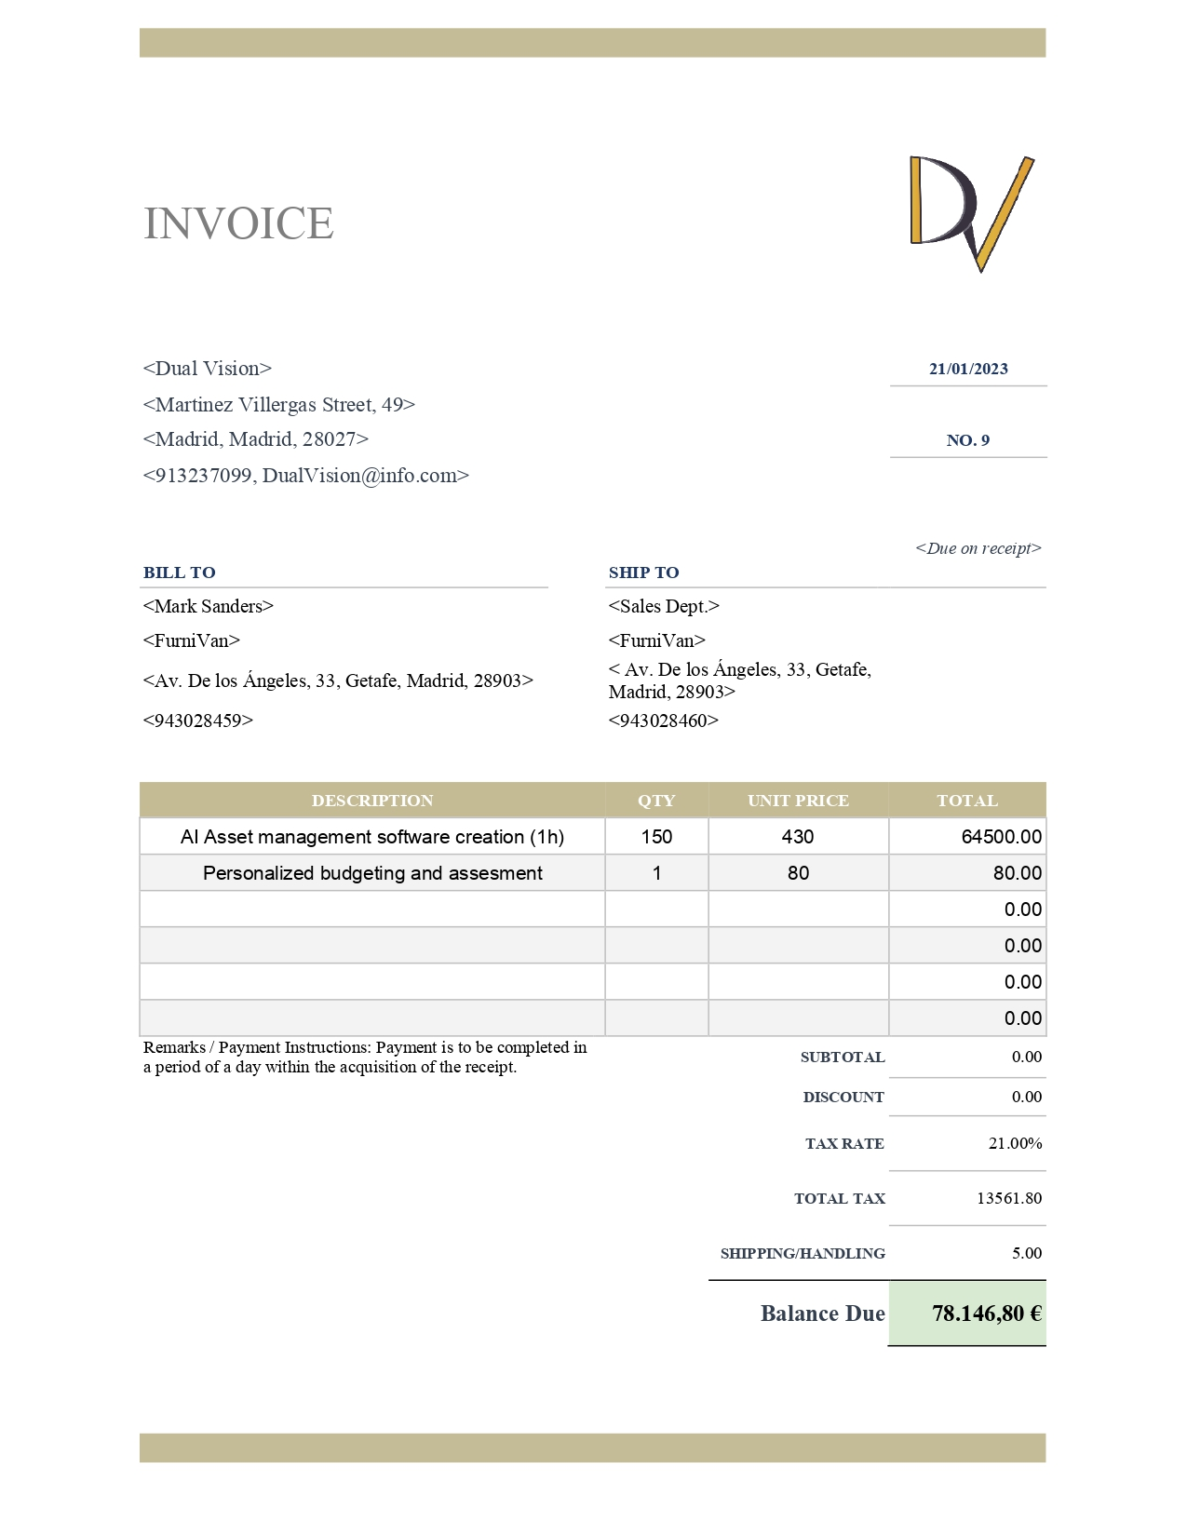

**I. MARKET ANALYSIS**

**1. Describe your company's product and its characteristics.**

**Core:** Our product is a mobile app that allows you to test different furniture products in a given space thanks to the augmented reality. Furthermore, you may be able to add new furniture to the app so it is customizable.

**Quality:** Our app has been fully tested with different types of tests (unit, integration…).

**Price:** Our base software app customized with the furniture that a client may offer us and visually customized for the client has a cost of 15.000€. In addition, we offer annual maintenance in case something went wrong or new additions to this software, which vary from €1.000 per year (this includes only problems troubleshooting) to €3.000, which includes also the new additions the client, may want.

**Brand, name and graphic expressions:** In the launch screen, it will appear the logo of our customer (for example, Ikea) but below it, there will be a message that says, “Powered by DualVision”, which will make people read our name every time they open our app.

**Services:** In addition to the customization of the furniture displayed, we may implement new additions that our clients may ask for such as a statistics report, the implementation of users for every customer, etc.

**Product image:** The information that people may create about the company thanks to using our product is that we are very modern (thanks to using a brand new technology such as AR), useful, and simple.

**2. Indicate how you are going to calculate the sale price of your product.**

Our pricing method would be based on competition, because our software does not have many competitors but a growing demand. Given that, we believe that the software is overpriced and if we offer it at a lower price than our competitors do, we would still make a lot of profit**.** Therefore, our price would be a penetration price.

**3. Consumers**

**I. Define the market segment the company is targeting, its "target group" and the reasons that motivate consumption.**

**Geographic:** Located in Spain

**Demographic:** The final customer (of the companies that we would sell our product) should be people between 20 and 60 years old who can afford to buy furniture but at the same time are able to handle the technology that our software implies.

**Psychographic:** We don’t have an exclusive personality type, but we guess that the people who is more perfectionist or insecure should use our app more than other type of people

**Behavioral:** We aim for our product to be used most of the times that a target consumer wants to buy something from the stores that we sold our software.

**II. Identification of who is involved in the purchasing process: Prescribers, etc.**

Our goal is that through the distribution channels (for example, publicity in the store we sold our software) people, who in the end are our final customer, may realize about the app and due to the good experience they may have, recommend the app and the store to their closed ones.

That way, other stores will notice that the reason of the increasing sales of their rival is due to the use of our software and they would like to implement it in their businesses as well.

**4. The demand**

Identify the real and potential market of your company. It is possible that you do not have all the information for your geographical area of ​​action; in that case, you can extrapolate the data obtained from broader territorial areas.

https://www.ine.es/dyngs/INEbase/es/operacion.htm?c=Estadistica_C&cid=1254736176741&menu=ultiDatos&idp=1254735576692

Our real market nowadays is composed of real state agencies that have bought our app and have hired us to offer support. These agencies include RedPiso, Tecnocasa or FotoCasa.

Augmented reality is attracting more and more attention, so our potential market is growing exponentially in many areas. However, some of these areas are intertwined. For example, our main goal is to reach big companies like Ikea. Nevertheless, these companies also cover a great number of potential customers: homebuyers, people who want to restyle their houses or businesses…

Another crucial market is interior designing. It includes professionals who desire an easier and visual way to work or schools that could use this app as a teaching tool.

**5. Suppliers and Intermediaries**

Indicate which are the main suppliers and intermediaries of your business.

Our company has a direct relationship with our clients so there are no intermediaries. Therefore, or level of distribution channel is 0.

As a software development company, all the services we offer and need are online, so we do not need suppliers of products. However, we require a fast and efficient server to develop our software. Google Cloud supplies the platform we need.

Utilities:

Our network and cell phone provider are Movistar, since it has the best pricing according to our needs.

Furthermore, we have made an arrangement with PCMadrid, a local company, so they provide us their repair services anytime we need them for a fixed price per month.

**6. Competition**

Identify your competition, study it to learn from it and point out its weaknesses to overcome it.

Some businesses that constitute some of the strongest competition in the market:

* Invelon Augmented and Mixed Reality

Invelon specializes in providing AR software used in marketing and sales companies for the previewing of commercial products. Furthermore, they cover a greater extent of the market by providing visual show building augmented reality, which includes full user immersion through 360º tours. Along with virtual reality assistance and other functionalities, Invelon’s offer is wide and consistent with most AR advances while also providing hardware.

One of Invelon’s main weaknesses is its lack of fame when it comes to furniture AR. The company tries to excel in many different markets, which makes it vulnerable to sudden changes and other companies that specialize in specific areas. As a company, Dual Vision has no need to include all of these extra services, but instead can specialize in furniture displaying augmented reality software, thus perfecting it and creating a successful competitor.

* ACA España

ACA’s product, DecoVR, serves as an installable module for Deco, a virtual reality program that, not only uses augmented reality, but also allows the user an immersive experience with the use of a virtual reality headset. This permits the user visualize a 100% virtual version of their own house, along with added pieces of furniture or decoration.

However, the service ACA provides forcefully requires the use of a headset, which also takes up space. As a company, we aim for the maximum level of comfort for our clients, which will not want to purchase an expensive piece of hardware just to view a virtual and blocky version of their house. To make it as easy as possible, our code will be supported by most smartphones, having its functionality only one touch away.

* Ikea Kreative AR

While we still consider IKEA one of our potential customers, we must also recognize their business as a famous and big competitor, given they have also created their own augmented reality software, *Kreative*, to preview furniture. They hold a big quantity of our potential customers, mostly individual clients. However, they are unlikely to sell or share their code or apps, which means they will probably remain stagnant within their actual scope of the market.

We might be able to overcome its main weakness, which is that IKEA does not directly provide to other businesses, both technology and furniture-wise. In order to accomplish this, we will need to expand our work beyond providing code for specific businesses, which could be done by creating an application that would cater to several businesses, while creating a subscription or plan for them to purchase. This would pose many advantages and create further economic benefits for us.

**Conclusions: diagnosis of the initial situation**

The initial situation presents a heavy competition with diverse prices and company approaches to the augmented reality software market. There are quite a lot of businesses and the competition is fair, meaning there currently is not a monopoly or oligopoly.

**Make an assessment of the information collected.**

Although some of the listed companies are very well known and have been established within the market for some time, this does not mean Dual Vision cannot specialize in a certain aspect of augmented reality and provide easy access to it to their customers, both individual clients and businesses.

**II. MARKETING STRATEGIES**

**Describe some of the marketing strategies that you would adopt in your business idea.**

We are adopting an operational and differentiated marketing strategy because we want to reach several markets with very different needs. We are presenting all the functionalities of our software and the services our company offers to each type of customer.

The best way to capture customers is by letting users and companies experience the benefits of our app at a reasonable price. Then, we offer payment plans: basic, intermediate, premium. Each plan is destined to different markets as our services become more personalized.

**Describe what type of communication strategies you are going to use.**

Our communication strategies vary depending on the market we are reaching. Companies require a direct approach. We need to contact the customer to show them first-hand the benefits of our software. We offer a personalized customer service, so we should explain face to face how we could improve or facilitate their business.

To reach individuals, it is more useful to advertise our product. In this case, we face a massive market with the common goal of refurbishing an area. Since our product is an app, we are promoting it mainly online, in real state agencies or furniture stores websites, other apps, games related to interior design…

Finally, there are some strategies that work for all markets, like gifts or discount coupons to attract new customers or activities that could improve our company’s image.

**III. ORGANIZATION OF BUSINESS ACTIVITY (MARKED GOODS AND / OR SERVICES)**

Briefly comment who your main suppliers are, what distribution channels you have chosen for your products. Have you considered having a minimum stock in the company of the different products you offer? Justify your answers.

As a software development company, all the services we offer and need are online, so we do not need suppliers of products. However, we require a fast and efficient server to develop our software. Google Cloud supplies the platform we need.

Our network and cell phone provider are Movistar, since it has the best pricing according to our needs.

Furthermore, we have arranged with PCMadrid, a local company, so they provide us their repairment services anytime we need them for a fixed price per month.

About the stock, as we provide a software program, we do not have a minimum or maximum stock.

**IV. ORGANIZATION OF HUMAN RESOURCES**

Describe the characteristics of the different work positions in the company and the composition of the workforce.

* **CEO**:

The CEO or chief executive officer is in charge of planning the strategies that will be implemented in a company, as well as the policies enforced. They are responsible for the entirety of the departments that conform a company, taking a leadership role whose whole purpose is to ensure the company succeeds.

* **FINANCIAL MANAGER**:

They are in charge of taking decisions regarding fund investment, project financing, performing data analysis, advising other managers on profitable ideas and keep the company financially healthy.

* **IT MANAGER**:

They oversee all aspects of computer-related work or tasks within a business, often leading programming projects.

* **MARKETING MANAGER**:

They are responsible for creating and implementing marketing plans or strategies in the company in order to attract potential customers or retain the ones the company already has.

* **HR MANAGER**:

They are in charge of directing the human resource department activities, which include hiring, interviewing staff, administering salaries and pay, benefits, leaves, etc. They also see that all company policies and practices are enforced.

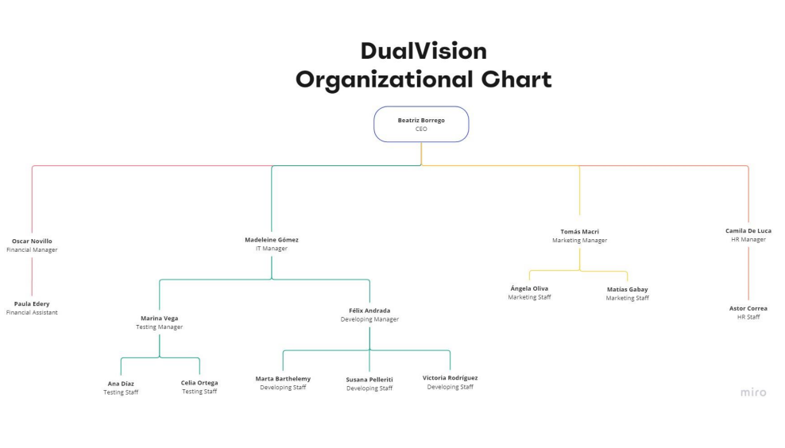Draw the organization chart of the company.